1. . SELECT * FROM `obat` ORDER BY tahun_kadaluarsa DESC.

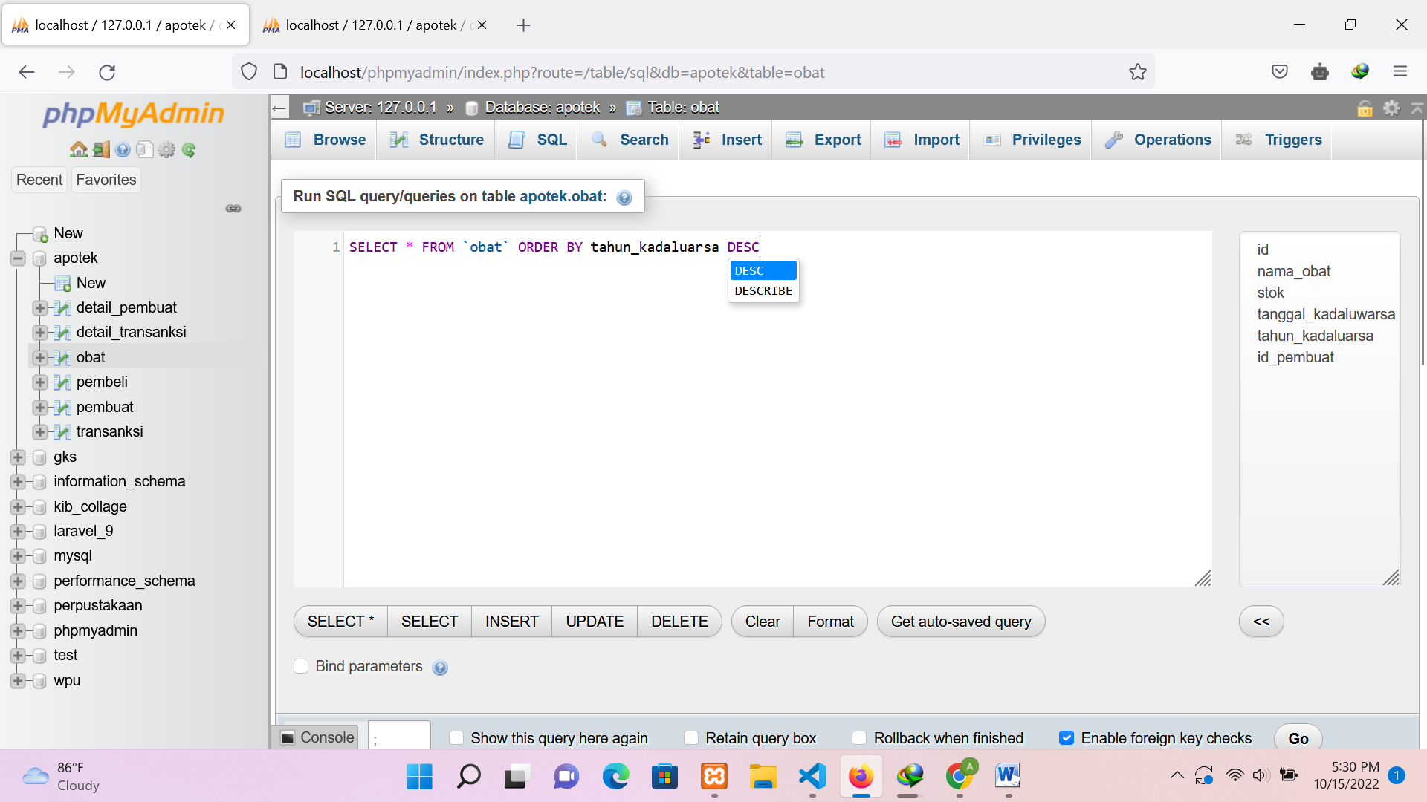

Hasil :

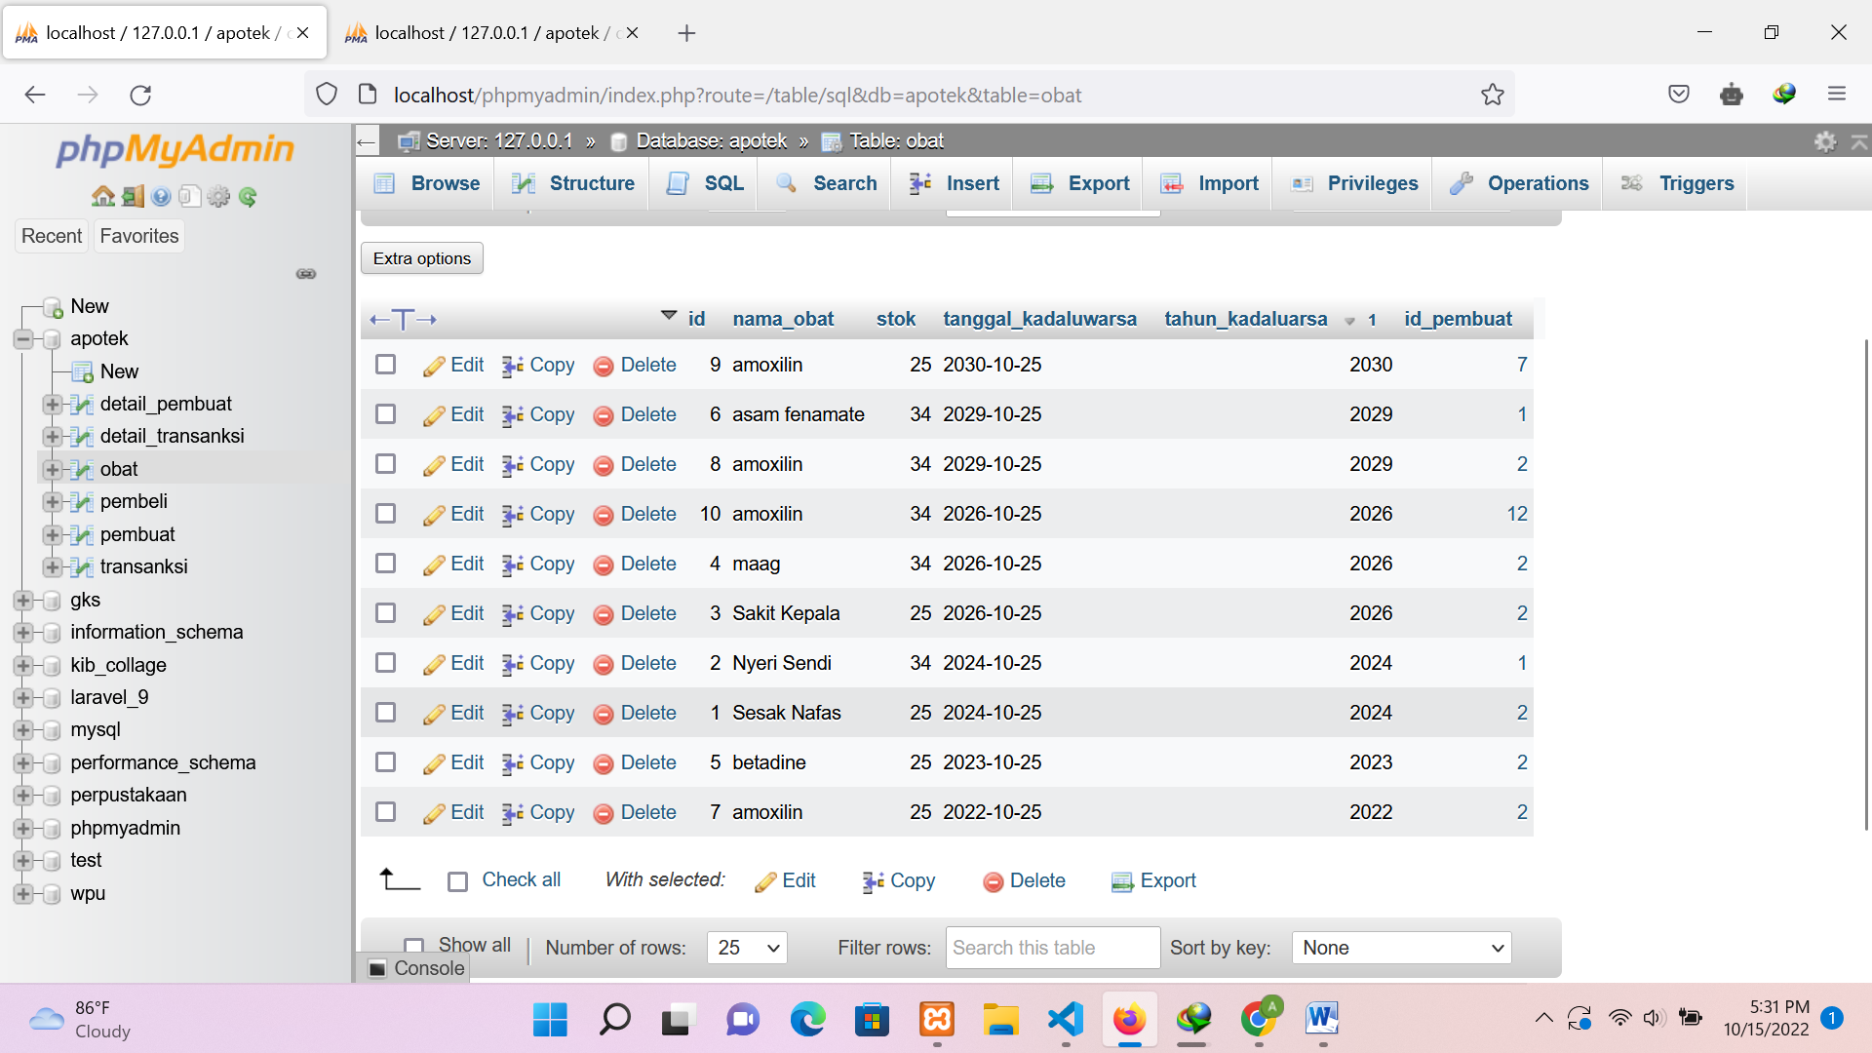

1. SELECT * FROM `obat` WHERE tahun_kadaluarsa >=2022 ORDER BY tahun_kadaluarsa ASC

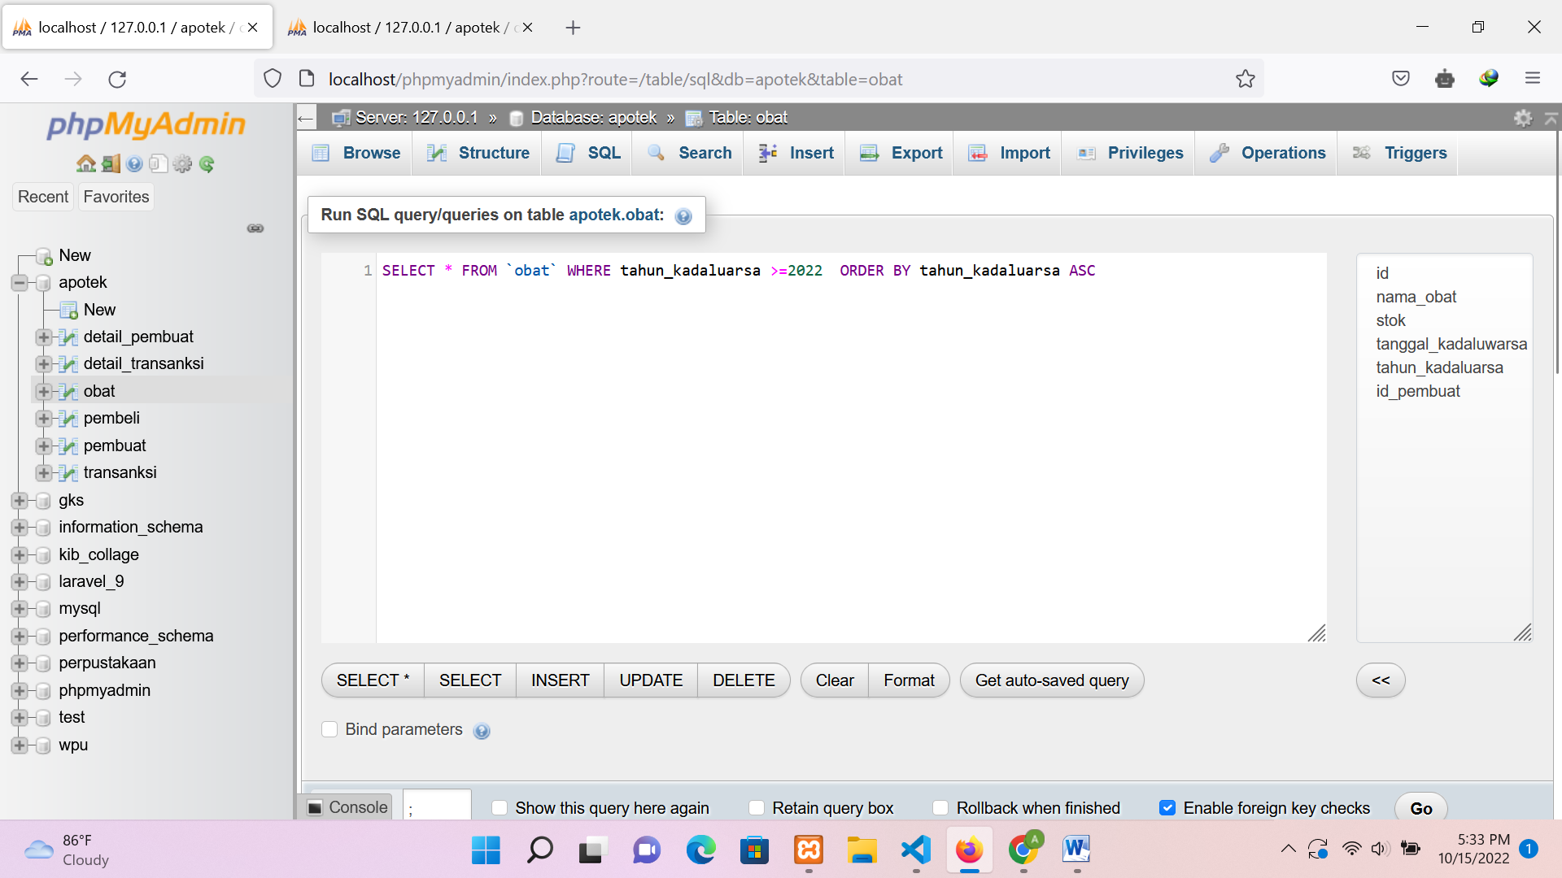

Hasil

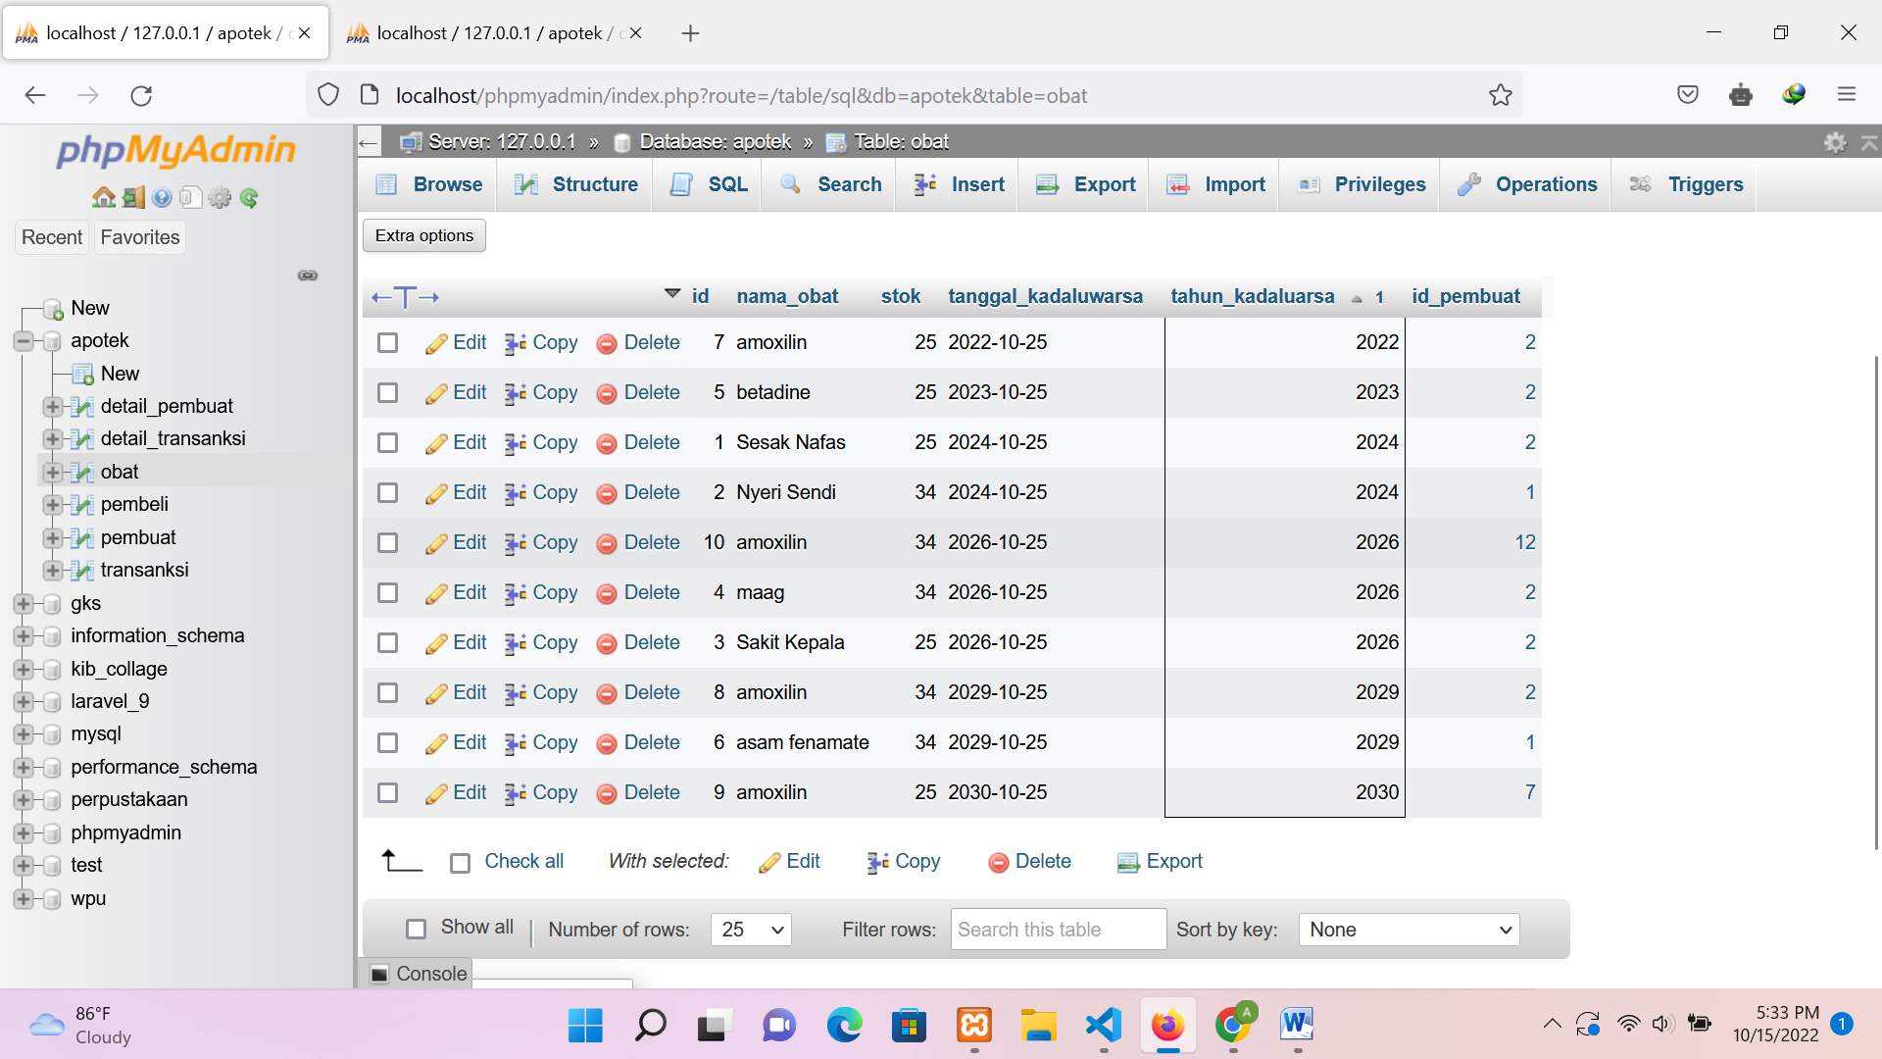

1. SELECT * FROM `obat` ORDER BY tahun_kadaluarsa ASC.

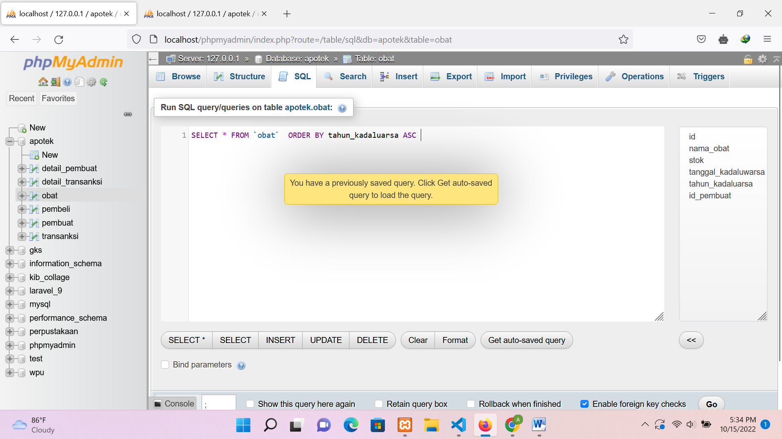

Hasil

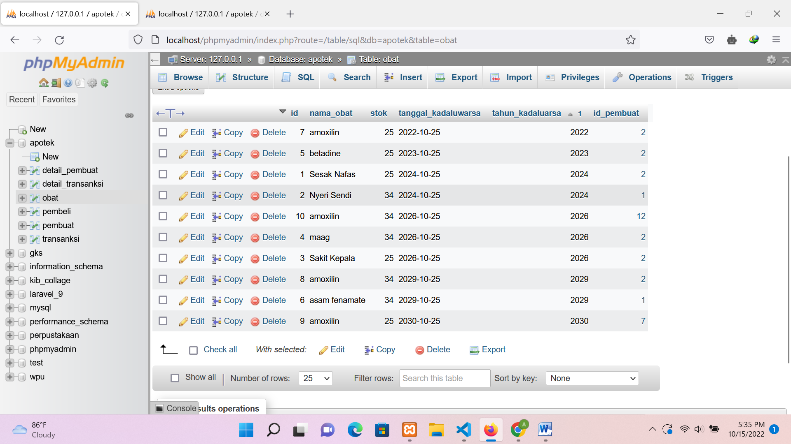

1. SELECT * FROM `obat` WHERE tahun_kadaluarsa LIKE '%2022%'.

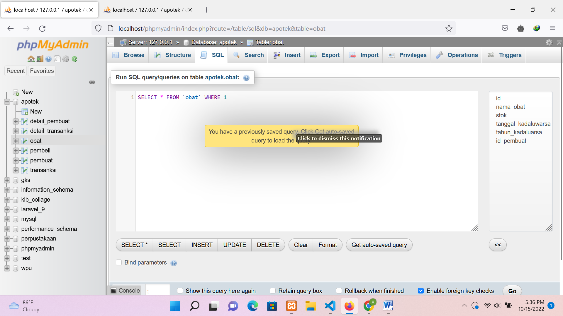

Hasil

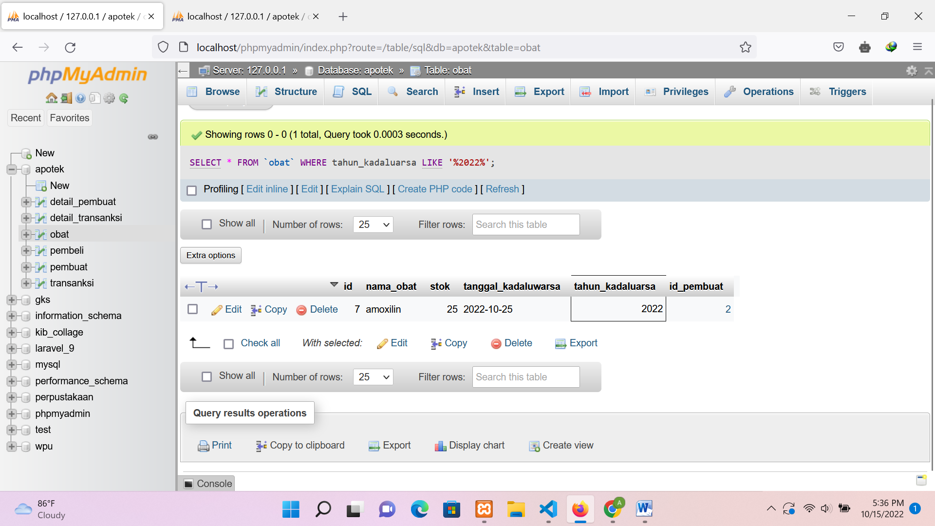

1. SELECT * FROM `obat` WHERE nama_obat LIKE '%amoxilin%'.

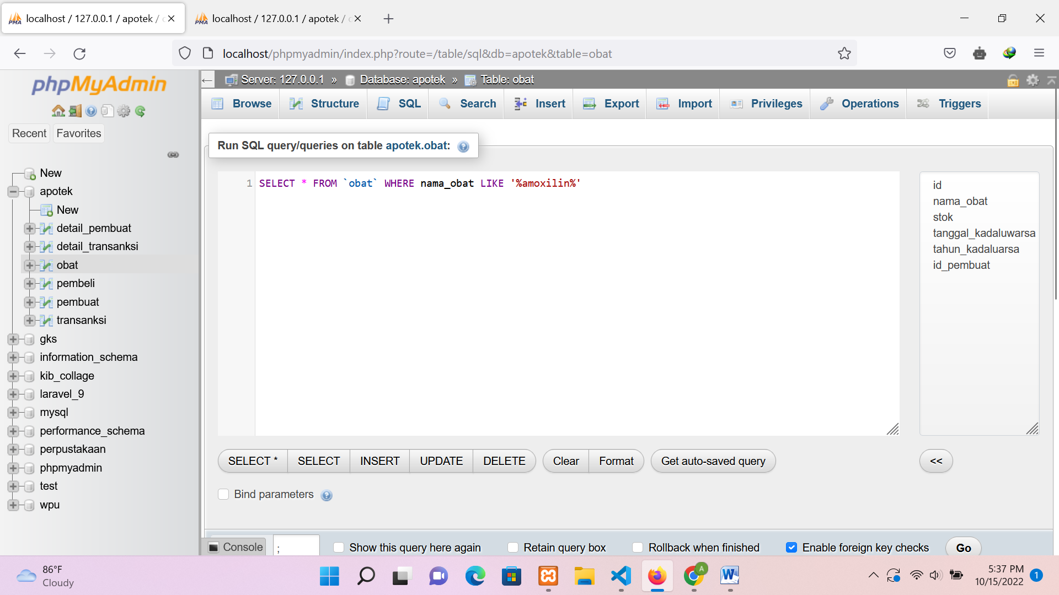

Hasil

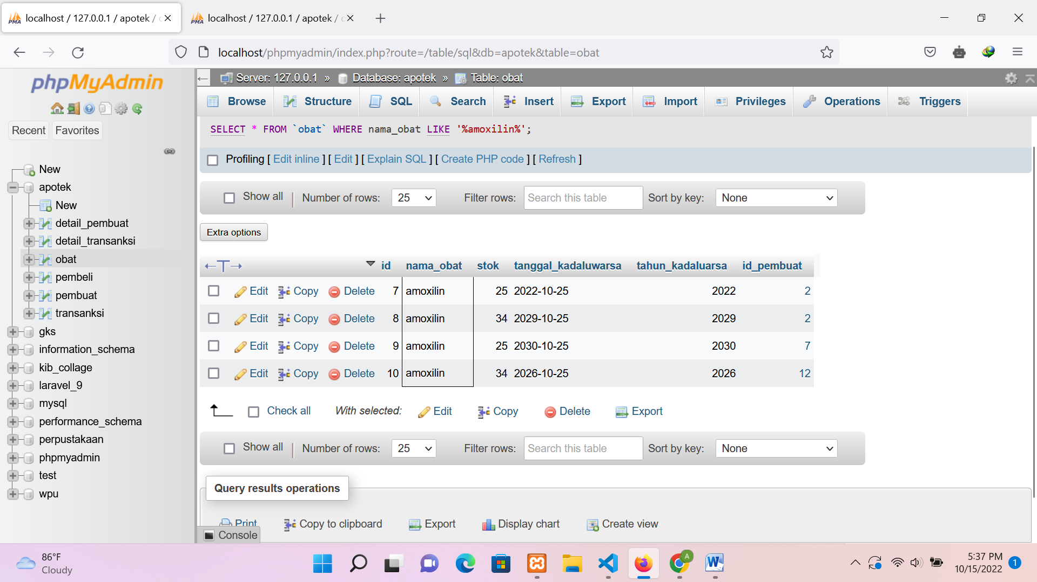

1. SELECT nama_obat, SUM(stok) as total FROM `obat`GROUP BY nama_obat.

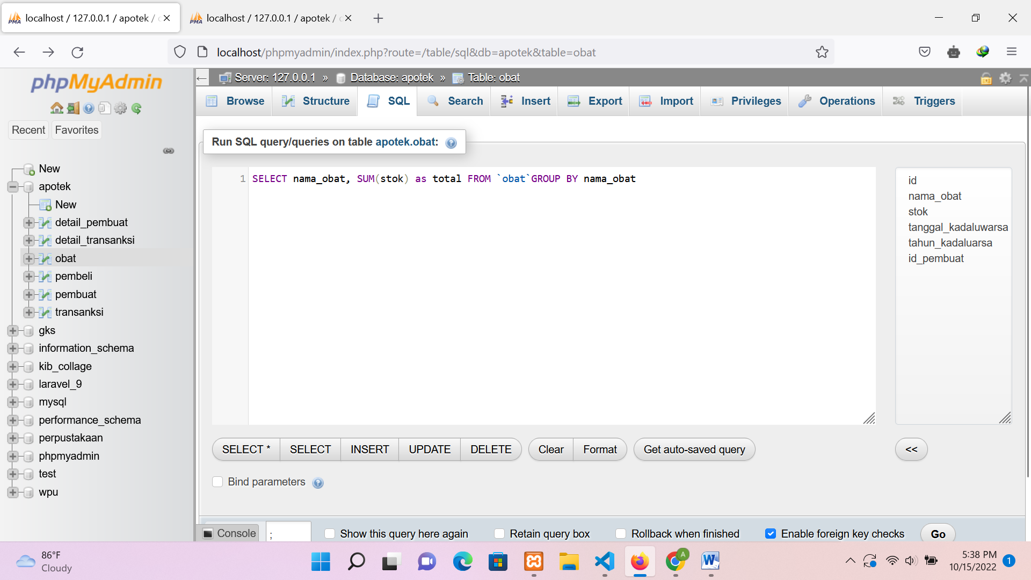

Hasil

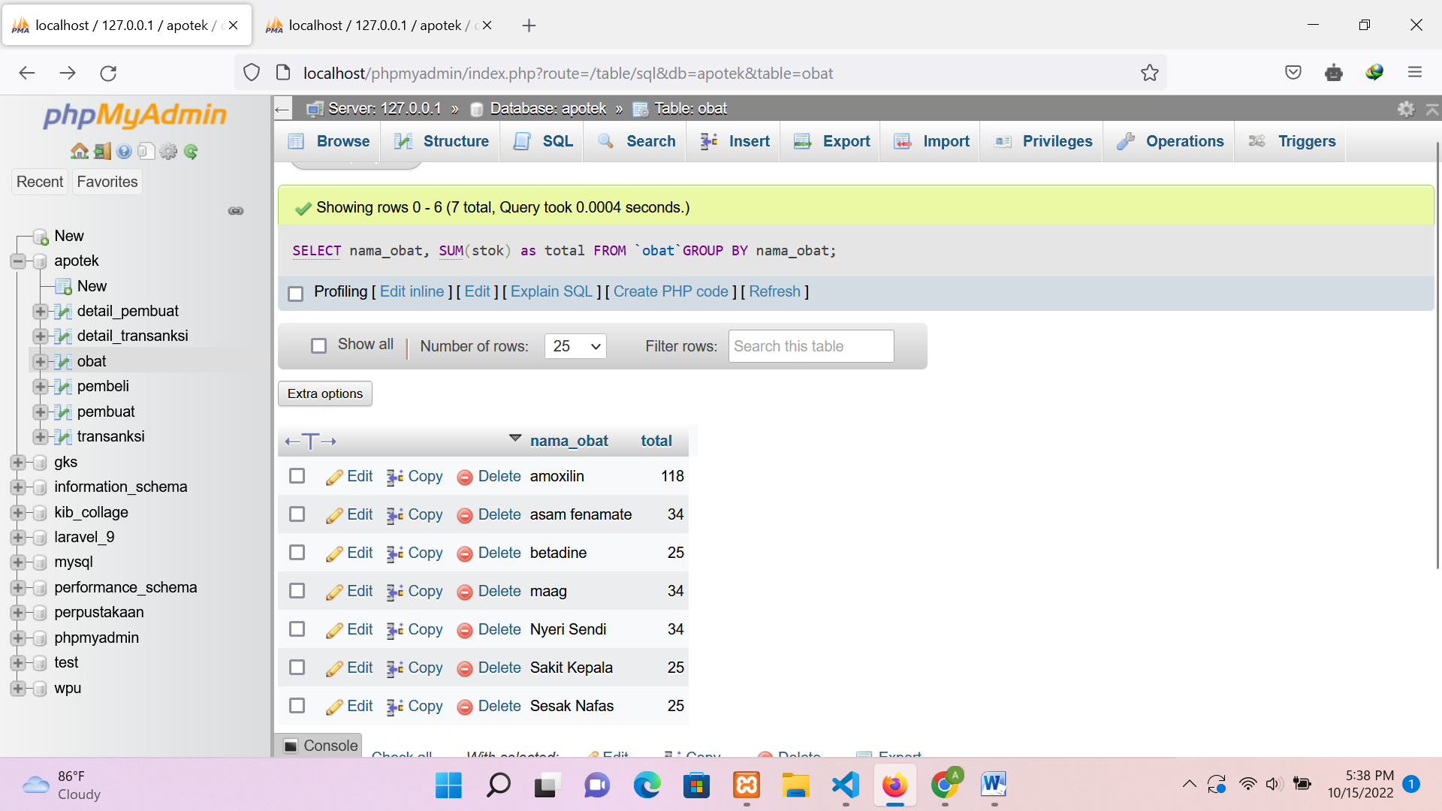

1. SELECT id_pembuat, SUM(stok) as total FROM `obat`GROUP BY id_pembuat.

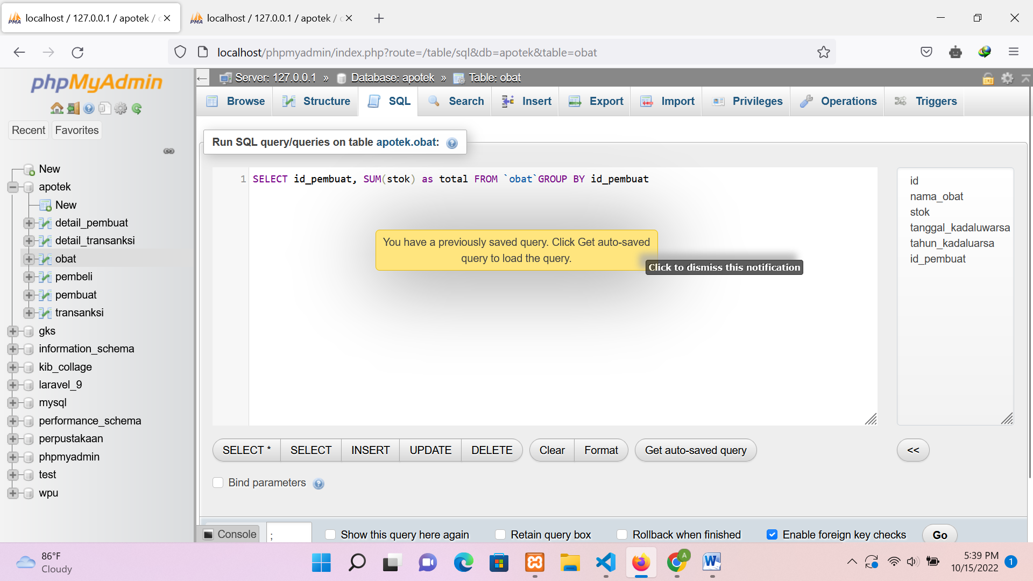

Hasil

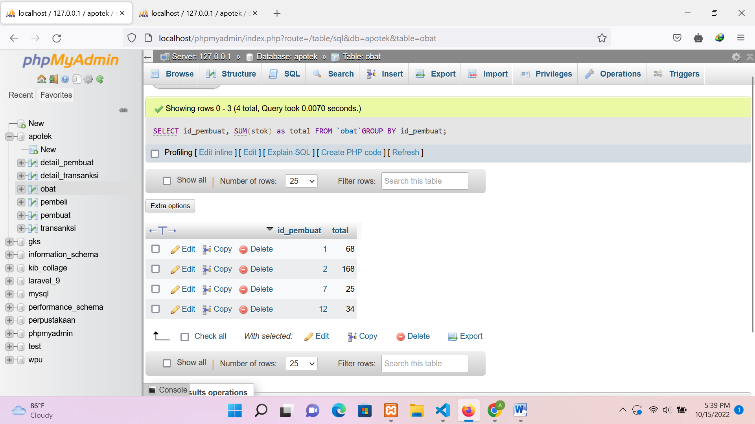

1. SELECT tahun_kadaluarsa, SUM(stok) as total FROM `obat`

WHERE tahun_kadaluarsa >=2022 GROUP BY tahun_kadaluarsa ORDER BY tahun_kadaluarsa DESC.

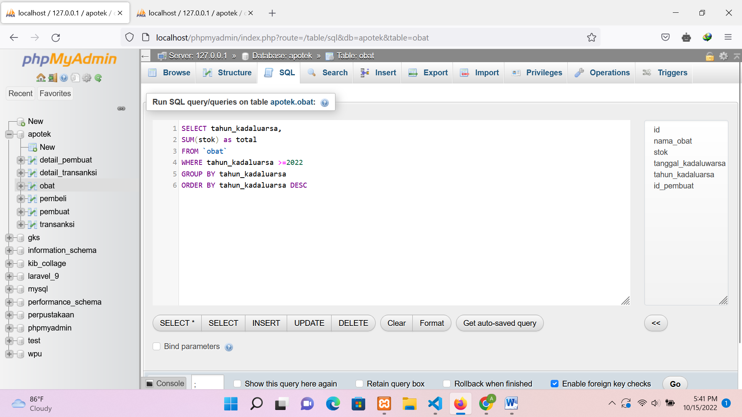

Hasil

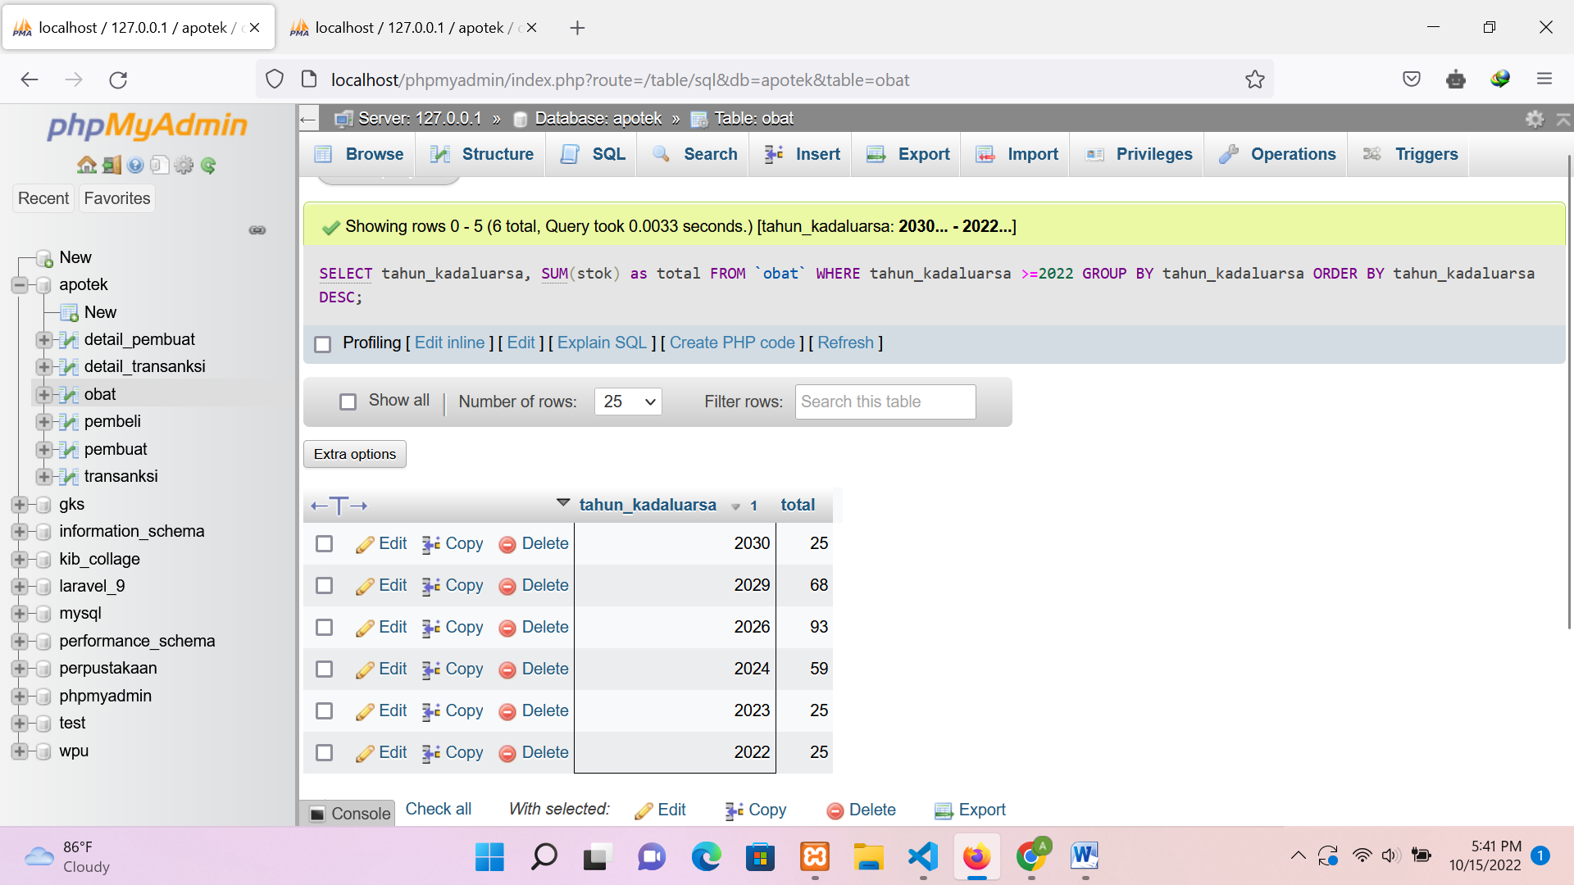

1. SELECT tahun_kadaluarsa, SUM(stok) as total

FROM `obat` GROUP BY tahun_kadaluarsa ORDER BY tahun_kadaluarsa ASC

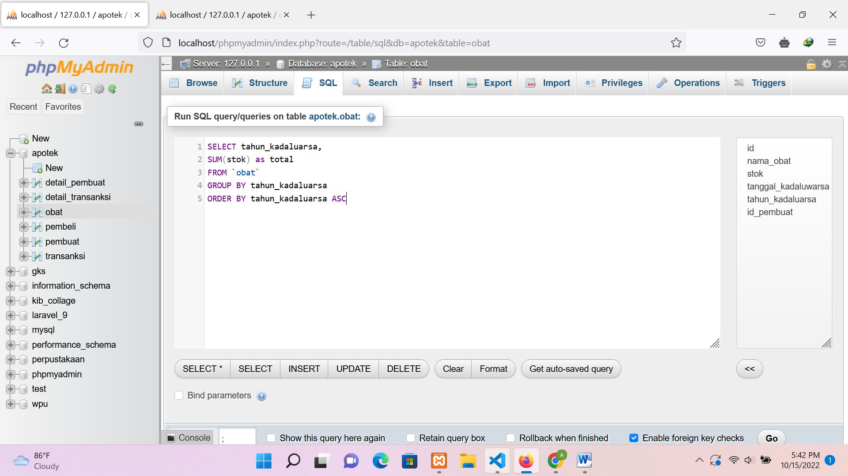

Hasil

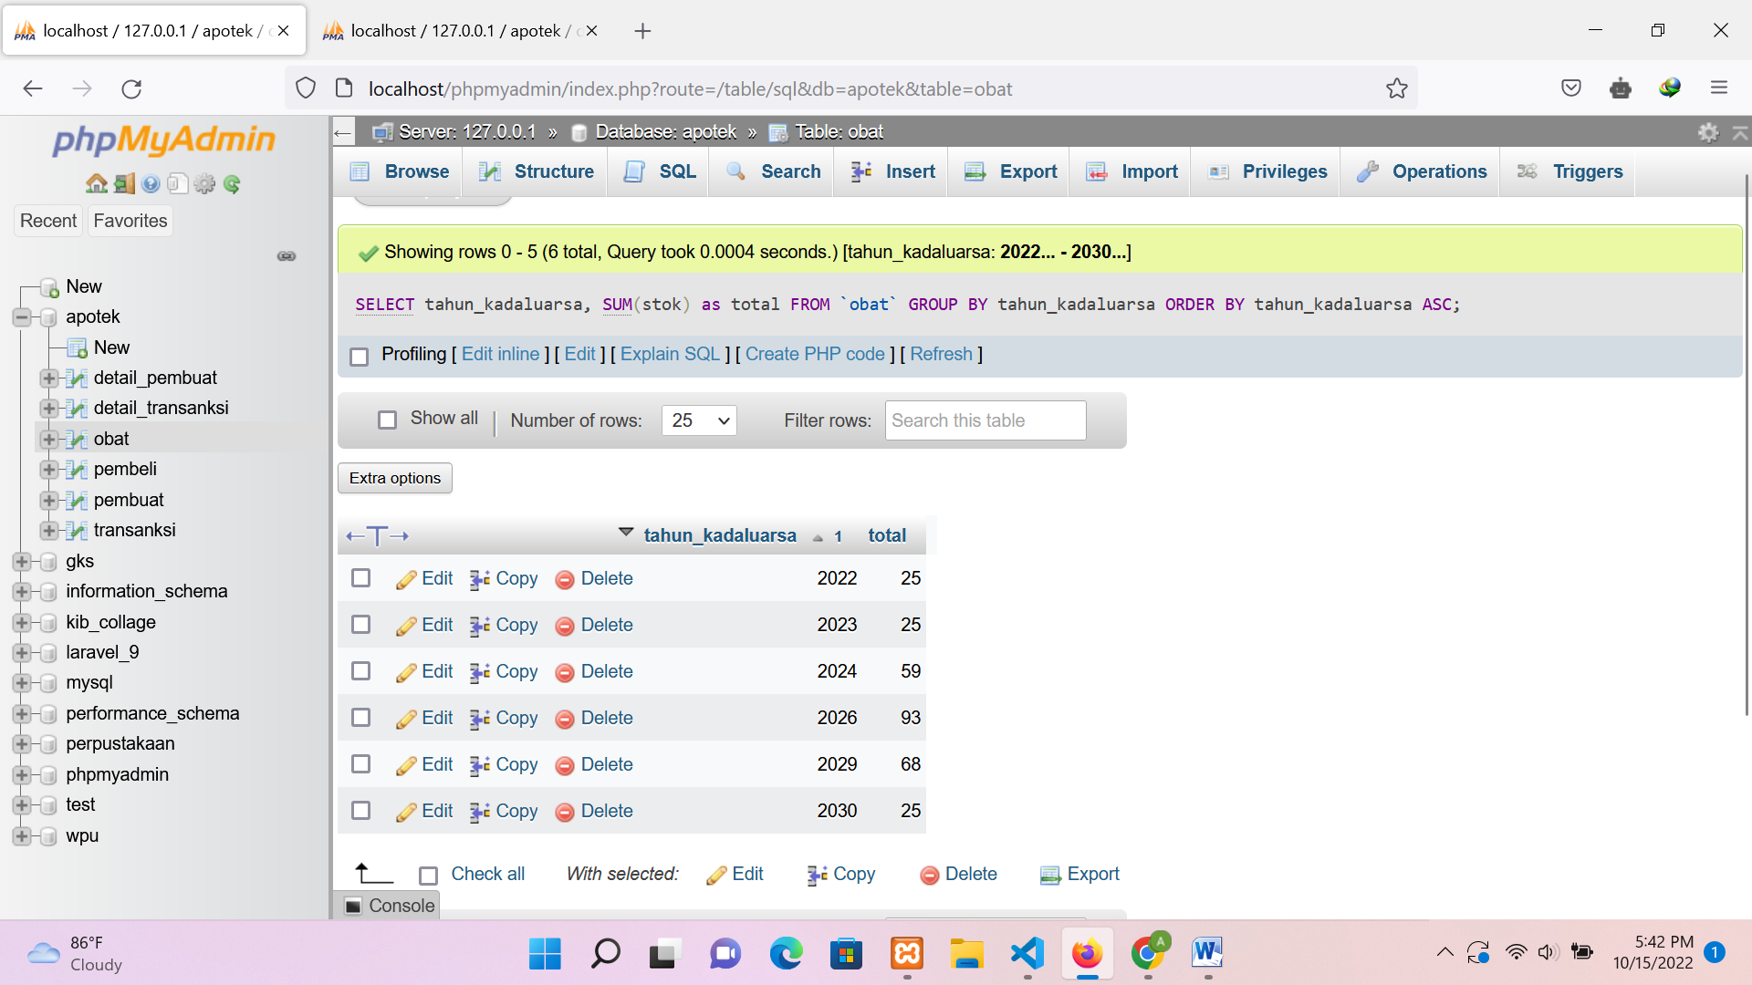

1. SELECT tahun_kadaluarsa, SUM(stok) as total FROM `obat`

GROUP BY tahun_kadaluarsa ORDER BY tahun_kadaluarsa ASC

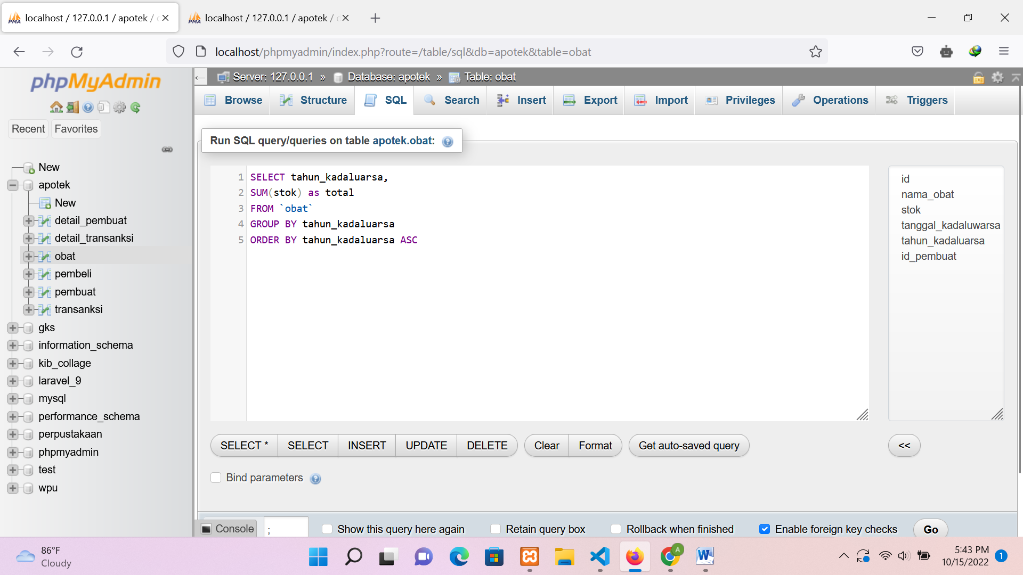

Hasil

